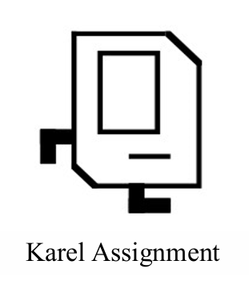

***Instructors:***

Motasim Aldiab

Fahed Jubair

***done by:***

Ghassan Yaseen

Abstract

This Report is to explains Karel, the Karel assignment and the solution that I used for it.

Introduction

This report talks about how can divide any map into the required shape and provide the solution for it. This report also aims to highlight the optimizations conducted within the code to reach the optimal solution.

Problem

This section aims to explain the Karel robot, and what is the Assignment

Karel

Karel the Robot, created by Richard E. Pattis in 1981, serves as an introductory platform for teaching programming to novices. Accompanied by the book "Karel the Robot: A Gentle Introduction to the Art of Programming," this educational tool focuses on core programming concepts. Its design simplifies the learning experience by reducing the intricacies of conventional programming language syntax.

The Assignment

The Assignment is dividing the map into 4 equally sized chambers if possible, and if not divide it into the next biggest number (3, 2, or 1) of equally sized chambers, it should be optimized:

- Karel should achieve the lowest number of moves.

- You should minimize the number of lines in the code.

- Use the lowest possible number of beepers.

The Solution

This section aims to provide all the possible cases and how every one of them was solved.

Size is even x even

In figure 1 we can see a map with size 10x10.

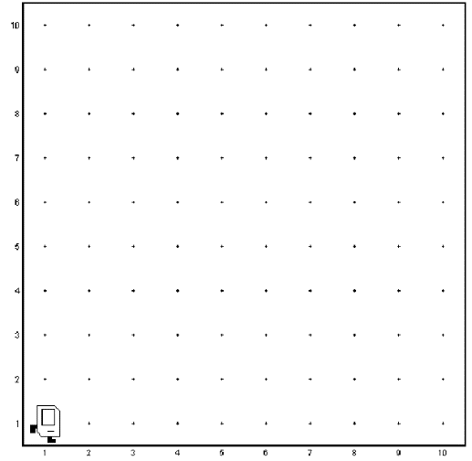

Figure 1

In This case we can divide the world into 4 equally sized chambers, but it is necessary to use double lines of beepers along both the width and the height to create the divisions, as shown in figure 2:

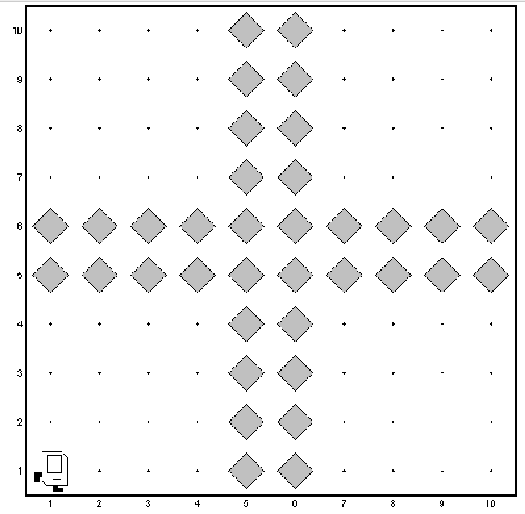

Figure 2

Size is odd x odd

In figure 3 we can see a map with size 7x7.

Figure 3

In This case we can divide the world into 4 equally sized chambers, and we used only one line of beepers along both the width and the height to create the divisions, as shown in figure 4:

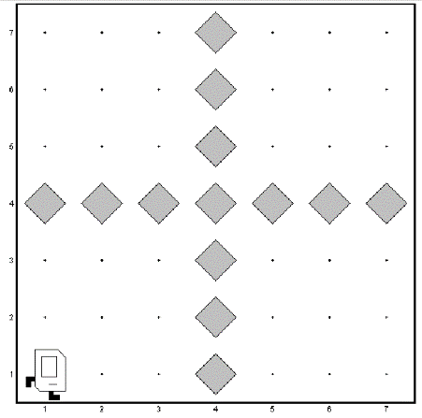

Figure 4

Size is odd x even

In figure 5 we can see a map with size 7x10.

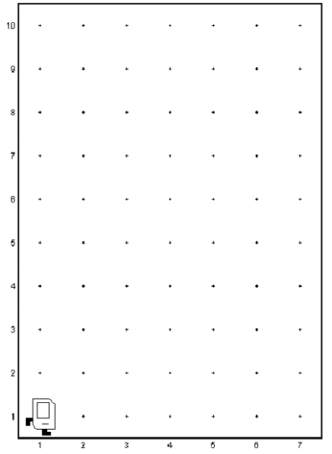

Figure 5

In This case we can divide the world into 4 equally sized chambers, and we used only one line of beepers for the height and double lines for width to create the divisions, as shown in figure 6:

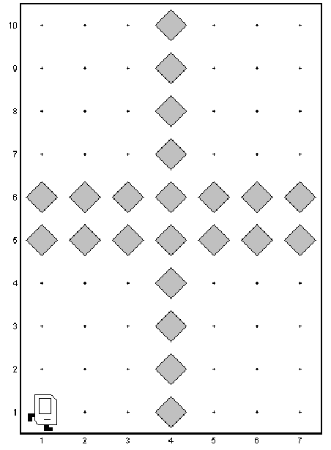

Figure 6

Size is even x odd

In figure 7 we can see a map with size 8x7.

Figure 7

In This case we can divide the world into 4 equally sized chambers, and we used double lines of beepers for the height and one line only for width to create the divisions, as shown in figure 8:

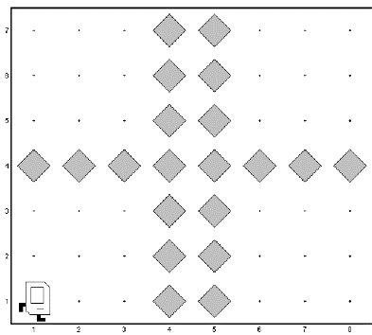

Figure 8

Size is 2x2

In figure 9 we can see a map with size 2x2.

Figure 9

In This case we can divide the world into 2 equally sized chambers, and we used single lines of beepers to create the divisions, as shown in figure 10:

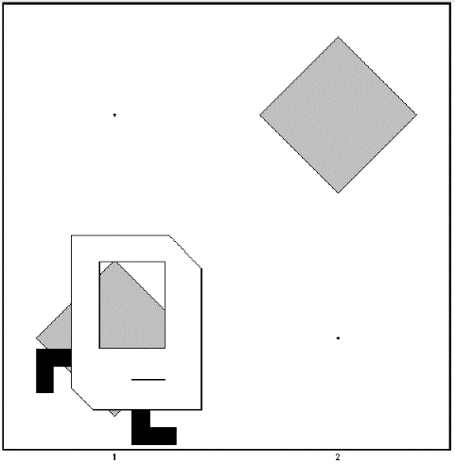

Figure 10

Size Divide into 4

In This case we can divide the map into 4 equally sized chambers if we can, as 4 squares, we used a map of 1x11as shown in figure 11, map of 2x12 as shown in figure 12:

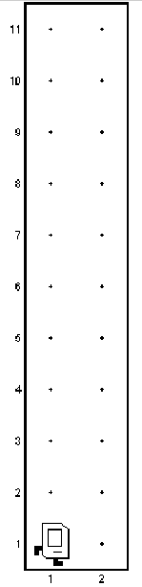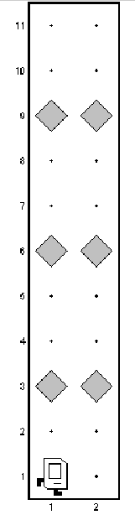

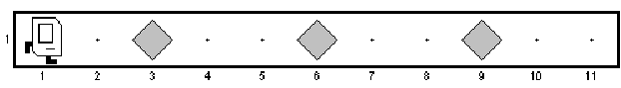

Figure 12

Figure 11

Size Divide into 3

In This case we can divide the map into 3 equally sized chambers if we cannot divide them on 4, as 3 squares, we used a map of 5x2 as shown in figure 13, map of 2x5 as shown in figure 14:

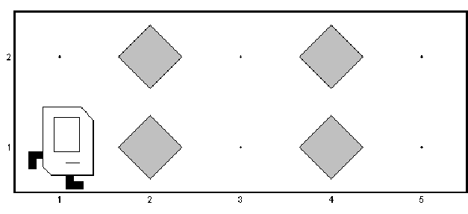

Figure 13

Figure 14

Size Divide into 2 odd

In This case we can divide the map into 2 equally sized chambers if we cannot divide them on 4 and 3, as 2 squares, we used a map of 3x2 as shown in figure 15, map of 1x3 as shown in figure 16:

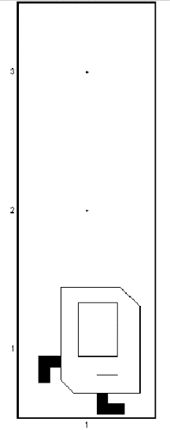

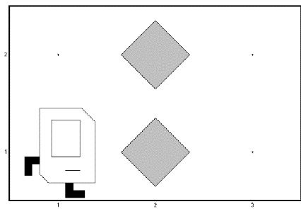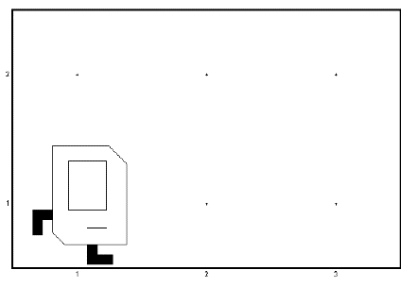

Figure 15

Figure 16

Size Divide into 2 even

In This case we can divide the map into 2 equally sized chambers if we cannot divide them on 4 and 3, as 2 squares, we used a map of 1x6 as shown in figure 17 map of 2x6 as shown in figure 18:

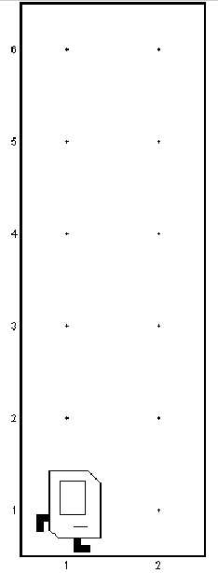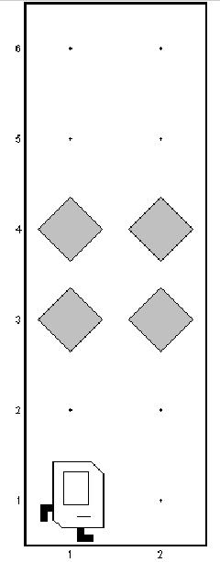

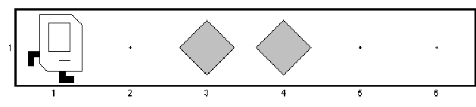

Figure 17

Figure 18

Optimizations

1. calculate the Height and the width of the map using those methods

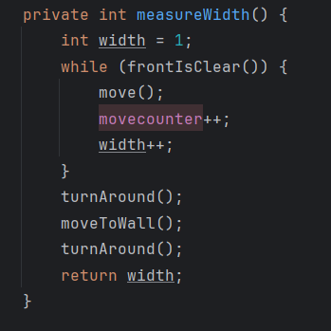

1. We use those two methods to move to the row and the column that we want.

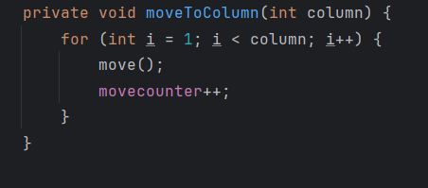

1. We use this method to move to the wall.

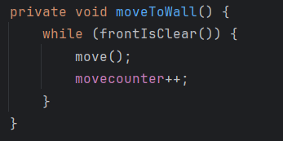

1. We use those two methods to put Beeper for the line (row or column) that we want.

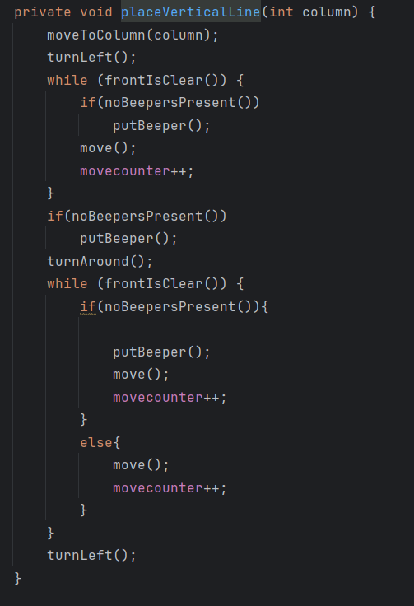

1. We use the divided method to divide the number that we want (4 , 3 ,2 ,1).

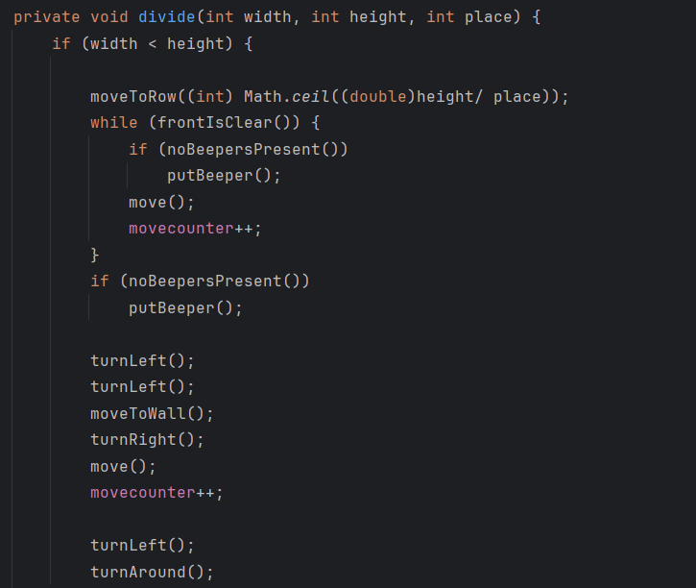

1. We use the divideIntoTwo to divide the map the 2 blocks if it is odd we put one line in the between and if double line in between as the code.

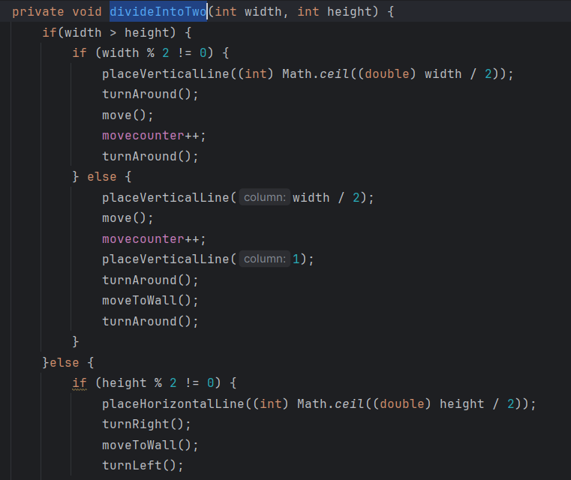

1. We use the divideIntoThree to divide the map the 3 blocks by putting a single line in between as the code.

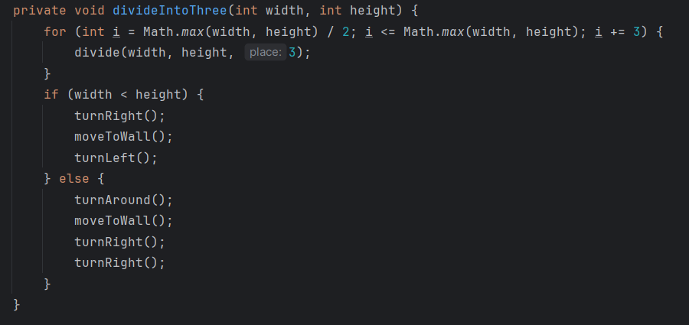

1. We use the divideIntoFourLine to divide the map the 4 blocks by putting a single line in between as the code only if one of the width and height less than or equal to 2.

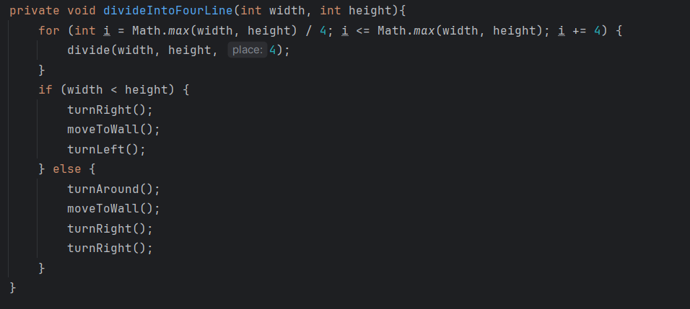

1. We use the divideIntoFour Method to cut the map to 4 blocks if the height and the width more than 2 and choosing it is odd or even.

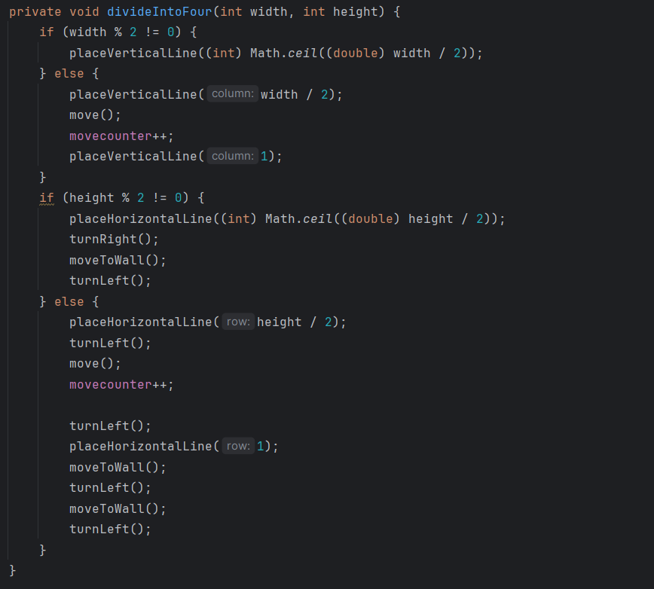

1. We use this method to cut the map if the Hight and width is equals to 2.

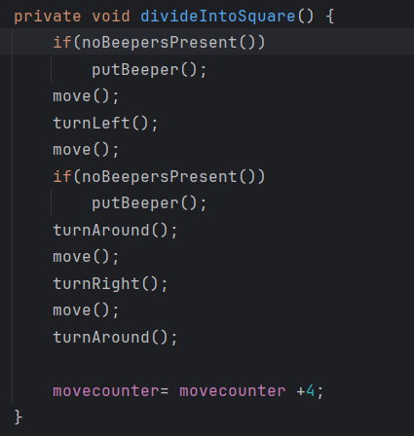

Conclusion

In this report, we have addressed the problem of dividing a given map into specific shapes, specifically into (4 ,3,2,1) rooms depending on what they can divide. The goal was to find optimal solutions while reducing the number of moves and lines of code.

We explored different scenarios based on the dimensions of the map and identified different cases, including even x even, odd x odd, odd x even, even x odd, divided on 4, 3, 2,1. For each case, we analyzed possible ways to segment the map and determined the optimal approach.